THIS LEAF IS ________________.

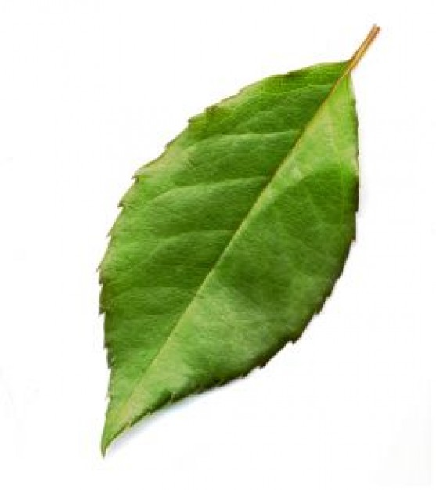

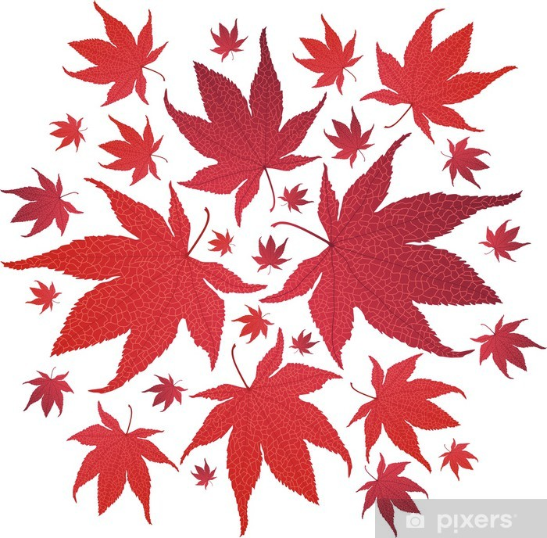THESE LEAVES ARE_____________ .