THE LEAF IS
THE LEAF HAS GOT A ______________________ MARGIN
ENTIRE
GLUE
THE LEAF
HERE
DENTATE
SERRATE
LOBED

THE LEAF IS A _______________ LEAF
SIMPLE
COMPOUND
THE LEAF HAS GOT A ____________________________ SHAPE
ELLIPTICAL
OVATE
CORATE
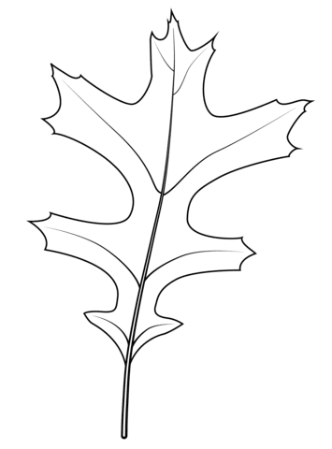
LANCEOLATE
PINNATIFID

