THE MOST IMPORTANT ADTs

- Study the main aspects of the ADTs TREE, BINARY TREE, GRAPH and WEIGHTED GRAPH described in the following table.

ADT | DATA | OPERATIONS | EXAMPLE
Tree | - Set of nodes connected with each other in a hierarchical way  - Each element is connected downwards to N nodes (children)  - Each element is connected upwards to 1 node (parent)  - Exception: the first node has no father (root)  - Some nodes have no children (leaves) | - Insert element (any position)  - Remove element (any position)  - Insertion and removal have to maintain the tree structure  - Search element | 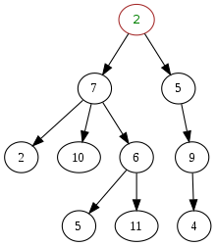
Binary tree | - Set of nodes connected with each other in a hierarchical way  - Each element is connected downwards to max 2 nodes (children)  - Each element is connected upwards to 1 node (parent)  - Exception: the first node has no father (root)  - Some nodes have no children (leaves) | - Insert element (any position)  - Remove element (leaf)  - Insertion and removal have to maintain the binary structure  - Search element | 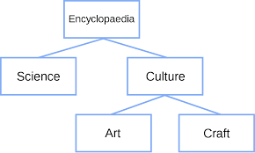
Graph | - Set of nodes connected with each other through edges (or arches or branches)  - Each node can be connected to N other nodes (N >=0) | - Insert element (any position)  - Remove element (any position)  - Insertion and removal of a node affects also the edges connecting it to the rest of the graph  - Search element  - Search a path between two nodes | 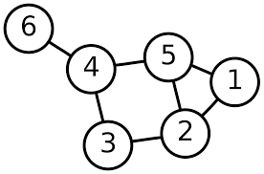
Weighted graph | - Set of nodes connected with each other through edges (or arches or branches)  - Each element can be connected to 1 or to N other nodes  - Each edge has a value (weight) | - Insert element (any position)  - Remove element (any position)  - Search element  - Calculation of the path between two nodes using weights | 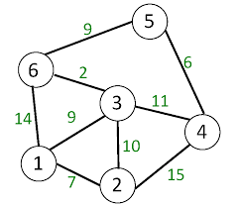

- Complete the table with the ADTs you already know (Recap).

ADT | DATA | OPERATIONS | EXAMPLE
List
Queue
Stack

