 | CLIL TEST | Surname
 | Teacher Corrente Maria Luisa | Name

Create the following structure:
Surnamename
images
index.html

chris.jpg
dom.jpg
matt.jpg
muse.jpg
pages
simulationtheory.jpg

dom.html
chris.html
matt.html
simulationtheory.html

- Page index.html

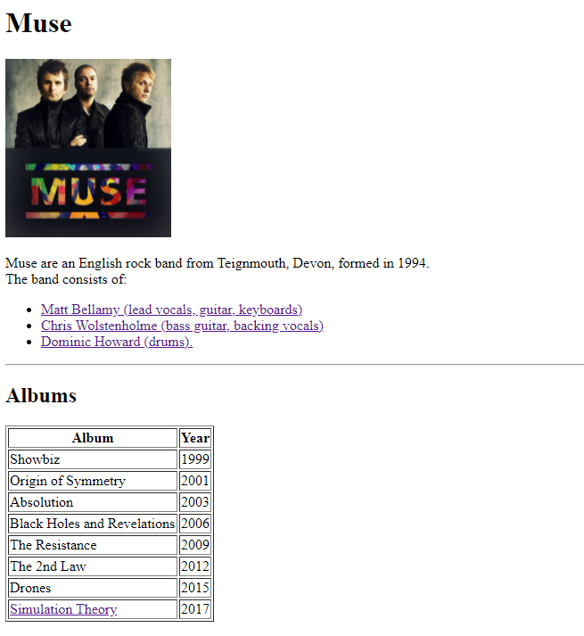
- The image is muse.jpg and it is 200px high;
- The bulletted list contains links to the page matt.html, chris.html, dom.html;
- The writing “Albums” is smaller than “Muse”;
- The last table row contains a link to the page simulationtheory.html.

- Page matt.html
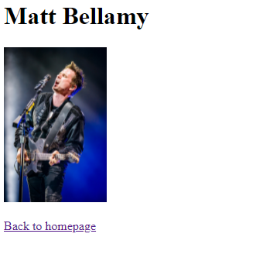
- The image is matt.jpg and it is 200px high;
- “Back to the homepage” is a link to index.html.

- Page chris.html
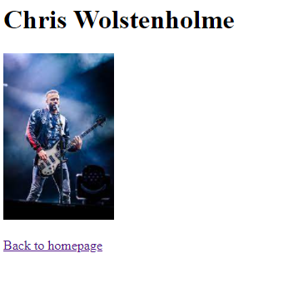
- The image is chris.jpg and it is 200px high;
- “Back to the homepage” is a link to index.html.
- Page dom.html
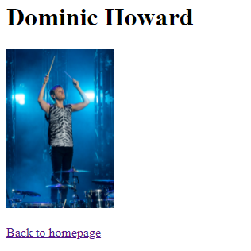
- The image is dom.jpg and it is 200px high;
- “Back to the homepage” is a link to index.html.

- Page simulationtheory.html
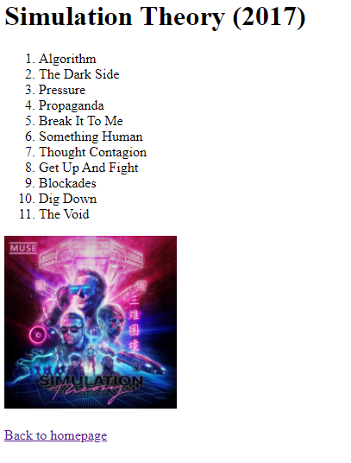
- The image is simulationtheory.jpg and it is 200px high;
- “Back to the homepage” is a link to index.html.

