 | CLIL | Surname
 | Teacher Corrente Maria Luisa | Name

Create the following structure and web pages:

index.html
mywebsite
DavidBowie.jpg
starman.html
images
pages

Page index.html:
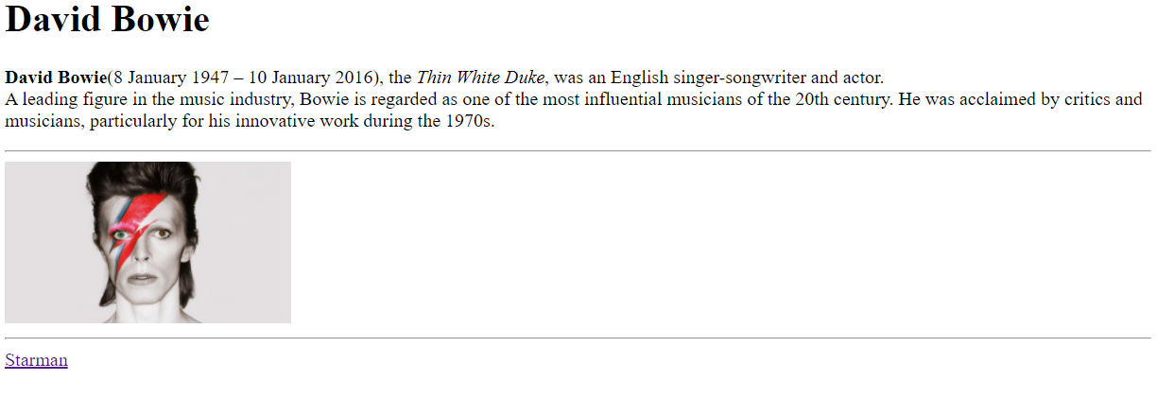
- Starman is a link to the page Starman.html that opens in another tab
- The width image is resized to 25%

Page Starman.html
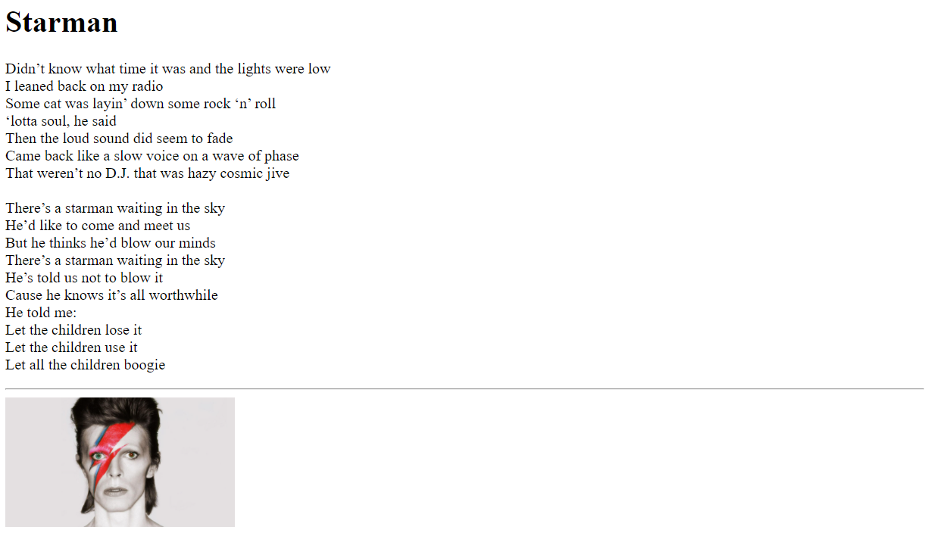
- The image is a banner to the index.html

