 | CLIL | Surname
 | Teacher Corrente Maria Luisa | Name

Compare your last work with this code:

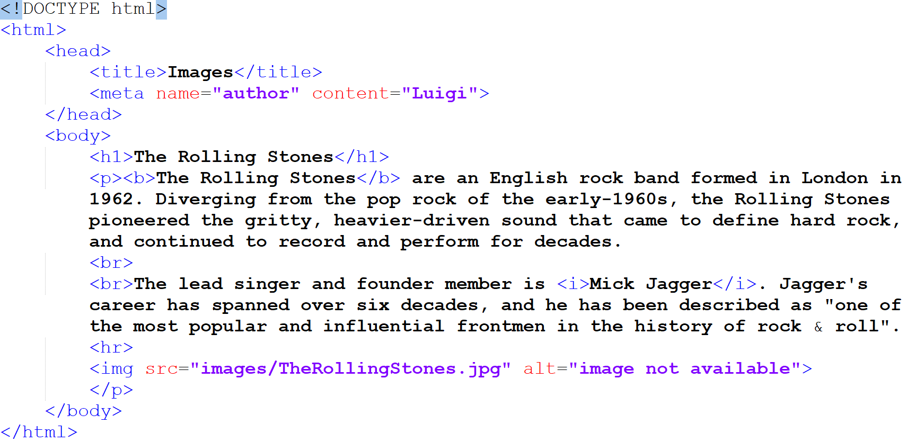

Did you make any mistake? Correct them.

