 | CLIL | Surname
 | Teacher Corrente Maria Luisa | Name

Create the following structure:

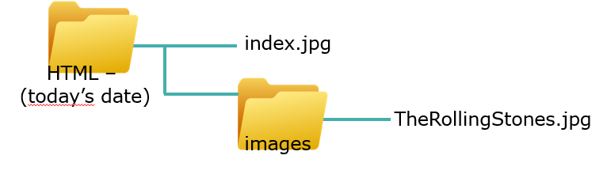

Create the following HTML page (remember to add the author of the page and and alternative text to the image):

