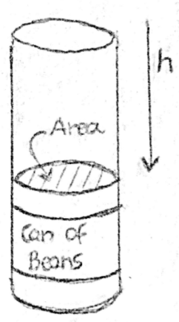
How do you find the pressure in a fluid?
Order the sentences
You'll often see this formula with the h and the g swapping places like this,
(sketch by the author)
$$P=dgh$$
The weight of the column of water above the can of beans is creating pressure at the top of the can.
Consider a can of beans in a pool as seen in the diagram.
According to the definition of pressure $P=\frac{F}{A}$
But $m_{w}$can be written in terms of the density and volume of the water.
Since density $d=\frac{m}{V}$, we can solve this for the mass of the water column $m_{w}=d_{w}V_{w}$
We know that the volume of a cylinder is $V=Ah$where A is the area of the base of the cylinder and h is the height of the cylinder. We can plug in V_{w}=Ah for the volume of water into the previous equation and cancel the areas.
The force F is the weight of the column of water above the can of beans. The weight of the column of water is $W=m_{w}g$
So $P=\frac{d_{w}V_{w}g}{A}$
So this formula would work equally well for any object in any liquid.
We get $P=\frac{d_{w}Ahg}{A}=d_{w}hg$

To sum up
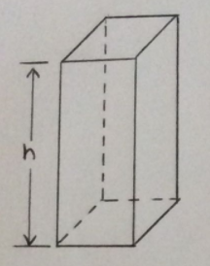
Static fluid pressure does NOT depend on the shape, total mass, or surface area of the liquid.

Pressure =$\frac{weight}{area}=\frac{mg}{A}= \frac{dVg}{A}=dgh$
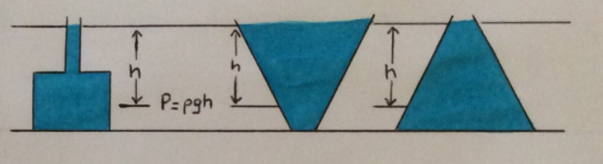
Volume = hA
Weight = mg
d = m / V
(sketch by the author)

Check the units!
Pressure = density x g x depth
[N/m²] = [ ] x [ ] x [ ]

