ARCH OF TITUS

The Arch of Titus is a 1st-century AD honorific arch, located on the Via Sacra, Rome, just to the south-east of the Roman Forum. It was constructed in c. 81 AD by the Emperor Domitian shortly after the death of his older brother Titus to commemorate Titus's official deification or consecratio and the victory of Titus together with their father, Vespasian, over the Jewish rebellion in Judaea. The arch, built in Pentelic marble and composed of a single archway, is richly decorated. The arch has provided the general model for many triumphal arches erected since the 16th century—perhaps most famously it is the inspiration for the Arc de Triomphe in Paris, France.
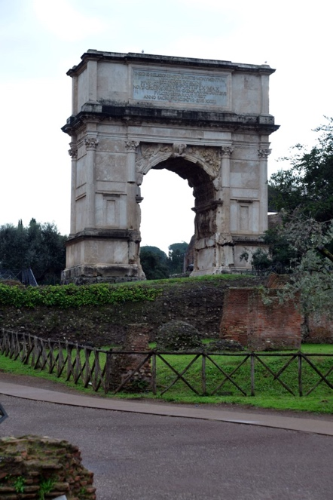

https://parcocolosseo.it/en/
https://en.wikipedia.org/wiki/Arch_of_Titus

THE TEMPLE OF SATURN

The temple belongs to the oldest sacral buildings on the Forum; the cult of Saturn having been practised on this spot since the Regal Period. The specific appearance of the temple visible today dates back to restoration measures in Late Antiquity; remains of both previous structures – the early Republican temple from the early 5th century B.C. and the early Augustan temple from the late 1st century B.C. – were incorporated into the structure of the temple from Late Antiquity.
First and foremost, the temple served as a cult site for Saturn, who was equated with the Greek god Kronos. In addition to its value as a cult site, the Temple of Saturn was also used by the Roman state (res publica) for administrative purposes. Especially important was its role as the Aerarium, i.e. the building in which the state treasury was located.

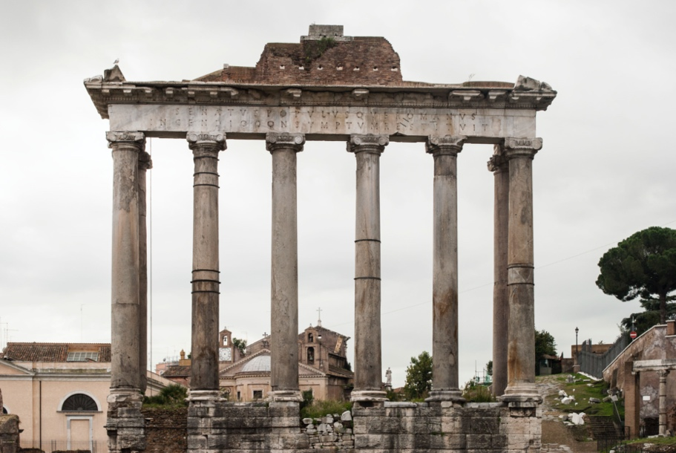

http://www.digitales-forum-romanum.de/gebaeude/saturntempel/?lang=en

THE CURIA JULIA
The Curia Julia (or senate house, was built in 44 BC, when Julius Caesar replaced Faustus Cornelius Sulla's reconstructed Curia Cornelia. The work, however, was interrupted by Caesar's assassination at the Theatre of Pompey, where the Senate had been meeting temporarily while the work was completed. The project was eventually finished by Caesar's successor, Augustus Caesar, in 29 BC.[1] T he roof, the upper elevations of the side walls and the rear façade are modern and date from the remodeling of the deconsecrated church, in the 1930s.

https://en.wikipedia.org/wiki/Curia_Julia

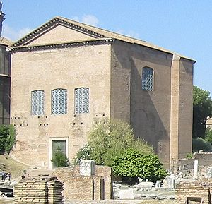

THE TRIUMPHAL COLUMN OF TRAJAN

Trajan's Column is a Roman triumphal column in Rome, Italy, that commemorates Roman emperor Trajan's victory in the Dacian Wars. It was probably constructed under the supervision of the architect Apollodorus of Damascus at the order of the Roman Senate. It is located in Trajan's Forum, north of the Roman Forum. Completed in AD 113. The victory of the Roman emperor Trajan over the Dacians in back-to-back wars is carved in numerous scenes that spiral around the 126-foot marble pillar. It’s a tale that reads like an ancient comic strip.
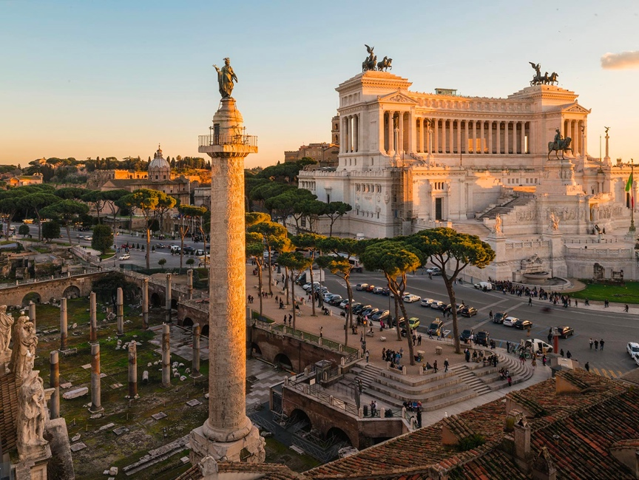

https://www.nationalgeographic.com/trajan-column/article.html
https://en.wikipedia.org/wiki/Trajan%27s_Column

