A FORUM WAS THE MAIN CENTRE OF ROMAN CITY. IT SERVED AS A PUBLIC AREA IN WHICH COMMERCIAL, RELIGIOUS, ECONOMIC, POLITICAL, LEGAL, AND SOCIAL ACTIVITIES OCCURRED. FORA WERE COMMON IN ALL ROMAN CITIES.
(forum=singular, fora=plural)

  - Volume 1 | Numero 1
Data

Roman forum and Imperial Fora

ROMAN FORUM
THE MAIN FORUM OF THE CITY OF ROME WAS THE FORUM ROMANUM LOCATED BETWEEN THE PALATINE HILL AND THE CAPITOLINE HILL. IT DATES BACK TO THE TIME OF THE TARQUIN KINGS
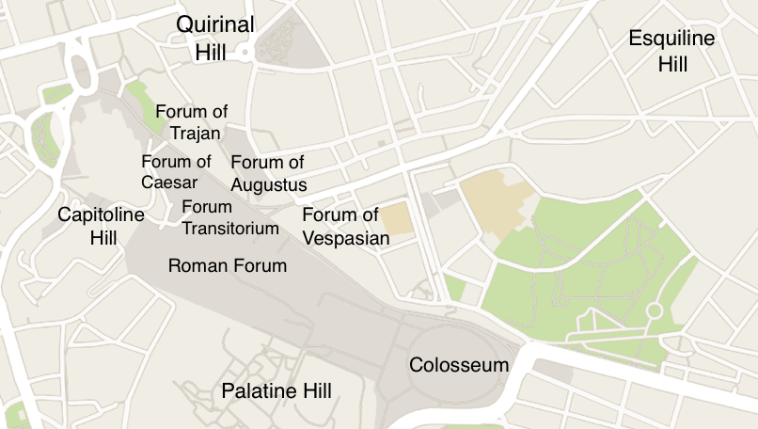
THE NEED TO RENEW THE MOST ANCIENT ADMINISTRATIVE AND LAW STRUCTURES AND TO ADAPT THEM TO THE CITY’S NEW DIMENSION WAS THE PRETEXT THAT JULIUS CAESAR USED TO FINISH A BRILLIANT INITIATIVE OF SELF-REPRESENTATION BY CREATING ONE OF THE BIGGEST ARCHITECTURAL COMPLEXES OF THAT TIME: THE FORUM OF CAESAR. HIS PROJECT REQUIRED THE ACQUISITION OF LAND AT THE FLANK OF THE CAPITOLINE HILL

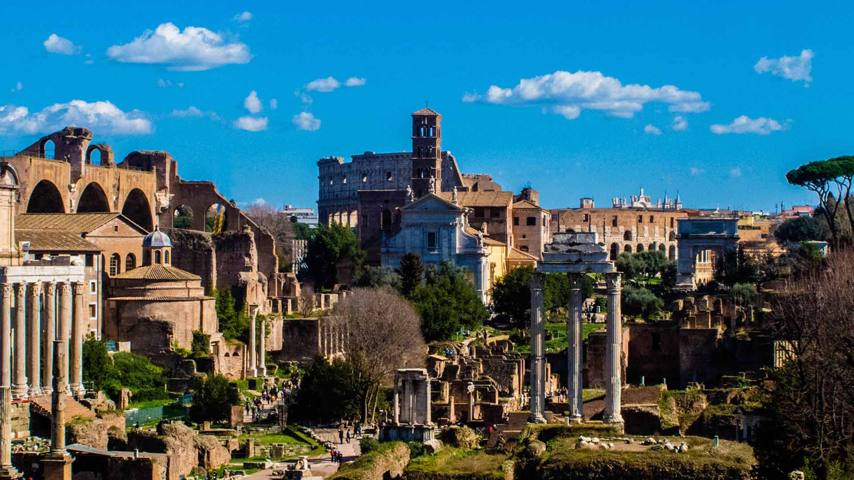
AFTER THIS, EACH EMPEROR ADDED HIS PERSONAL TOUCH, BUILDING NEW AREAS (NEW FORA), TRYING TO CONSTRUCT STATUARIES AND TEMPLES AND OTHER PUBLIC WORKS BY WHICH HE MIGHT BE REMEMBERED ( E.G. NERVA, VESPASIAN, TRAJAN)
Archaeological area of the Imperial Fora

SOME BUILDING YOU CAN FIND IN THE ROMAN FORUM AND IN THE IMPERIAL FORA ARE:

CURIA
The Meeting-Place of The Roman Senate

BASILICA
In Ancient Rome, basilicas were the site for legal matters and a place for business transactions

ARCH
The triumphal arch was a type of roman architectural monument built all over the empire to commemorate military triumphs and other significant events

THE TRIUMPHAL COLUMN
The triumphal column was a type of roman architectural monument built to commemorate the emperor’s military victories.
TEMPLE
From the Early Republican period the forum space saw the construction of key temples, which housed the state treasury.

Sources: https://www.turismoroma.it/en/places/archaeological-area-imperial-fora
https://www.khanacademy.org/humanities/ap-art-history/ancient-mediterranean-ap/ap-ancient-rome/a/imperial-fora
https://www.residenzamaritti.com/en/forum-of-caesar/

