U2_L1_ALL6
AERODYNAMICS of FLIGHT
Adapted from: https://www.courses.netc.navy.mil/courses/14014A/14014A_ch3.pdf

Aerodynamics is the study of the ________ that let an aircraft fly. These ______ can be understood by the physical laws of aerodynamics, which include ________________________________________

LAWS OF MOTION

Motion is the act or process of changing place or position. Simply put, motion is movement. An object may be in motion in relation to one object and motionless in relation to another. For example, a person sitting in an aircraft flying at 200 mph is _______________________________________. However, the person is in motion in relation _________________. Air has no force or power other than pressure when it's motionless. When air is moving, its force becomes apparent. A moving object in motionless air has a force exerted on it as a result of its own_______ It makes no difference in the effect whether an object is moving in relation to the air or the air is moving in relation to the object. The following information explains some basic laws of motion.

Newton's First Law of Motion
For an aircraft to fly, a force must be applied to it. It would remain at rest without an outside force. Once the aircraft is moving, __________ to bring it to a stop. It would continue in motion without an outside force. This willingness of an object to remain at rest or to continue in motion is referred to as ________.

Newton's Second Law of Motion
The second law of motion states that if an object moving with uniform speed is acted upon by an external force,________________________________________________ A heavier aircraft will accelerate more slowly than a lighter aircraft when an equal force is applied.

Newton's Third Law of Motion
The third law of motion (action and reaction) states that for every action (force) there is an equal and opposite reaction (force). This law can be demonstrated with a balloon. If you inflate a balloon with air and release it without securing the neck, as the air ______________________________________

BERNOULLI'S PRINCIPLE

Bernoulli's principle states that when a fluid flowing through a tube reaches a constriction or narrowing of the tube, the speed of the fluid passing through the constriction increases and___________________
Bernoulli's equation is essentially a more general and mathematical form of Bernoulli's principle that also takes into account changes in gravitational potential energy. We won’t derive this equation due to time issues. Bernoulli's equation relates the pressure, speed, and height of any two points (1 and 2, Figure 1) in a steady streamline flowing fluid of density ρ.

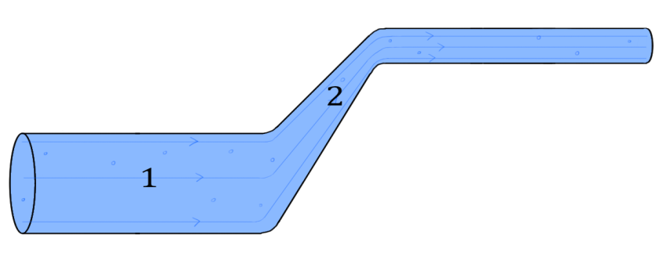
Figure 1: diagram showing a particular choice of two points (1 and 2) in a fluid

Bernoulli's equation is usually written as follows
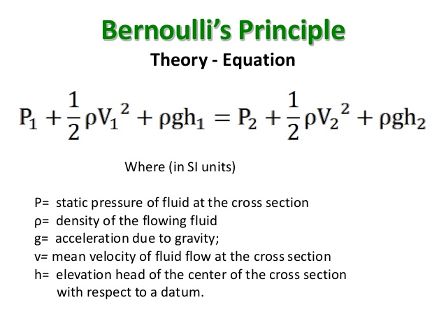
We should note here that Bernoulli's principle is contained within ___________. If we start with the equation above, and assume that there is no change in the height of the fluid, ρgh cancel if we subtract them from both sides. This simplified formula highlights Bernoulli's principle since if the speed v of a fluid is larger in a given region of streamline flow, the pressure P must be smaller in that region (which is _____________).

FORCES ACTING ON AN AIRCRAFT

Once an aircraft leaves the ground, it is acted upon by four aerodynamic forces; thrust, drag, lift and weight. Understanding how these forces work and knowing how to control them with the use of power and flight controls are essential to flight.
They are defined as follows:
• Thrust—the forward force produced by the _____________________. It opposes or overcomes the force of drag. As a general rule, it acts parallel to the longitudinal axis. However, this is not always the case, as explained later.
• Drag—a rearward, retarding force caused by disruption of airflow by the wing, rotor, fuselage, and other protruding objects. Drag opposes __________ and acts rearward parallel to the relative wind.
• Weight—the combined load of the aircraft itself, the crew, the fuel, and the cargo or baggage. Weight pulls the aircraft downward because of the force of gravity. It opposes lift and acts ______________ the aircraft’s center of gravity (CG).
• Lift—opposes the downward force of weight, is produced by the dynamic effect of the air acting on the airfoil, and acts perpendicular to the flightpath through the center of lift.

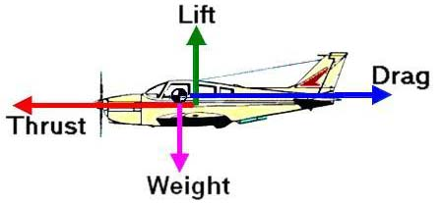
https://aviation.stackexchange.com/questions/42795/how-can-an-airplane-keep-going-forward-if-it-has-no-thrust

Figure 2: forces on an aircraft

