U1_L2_ALL3
Adapted from Wikipedia (https://en.wikipedia.org/wiki/Force).

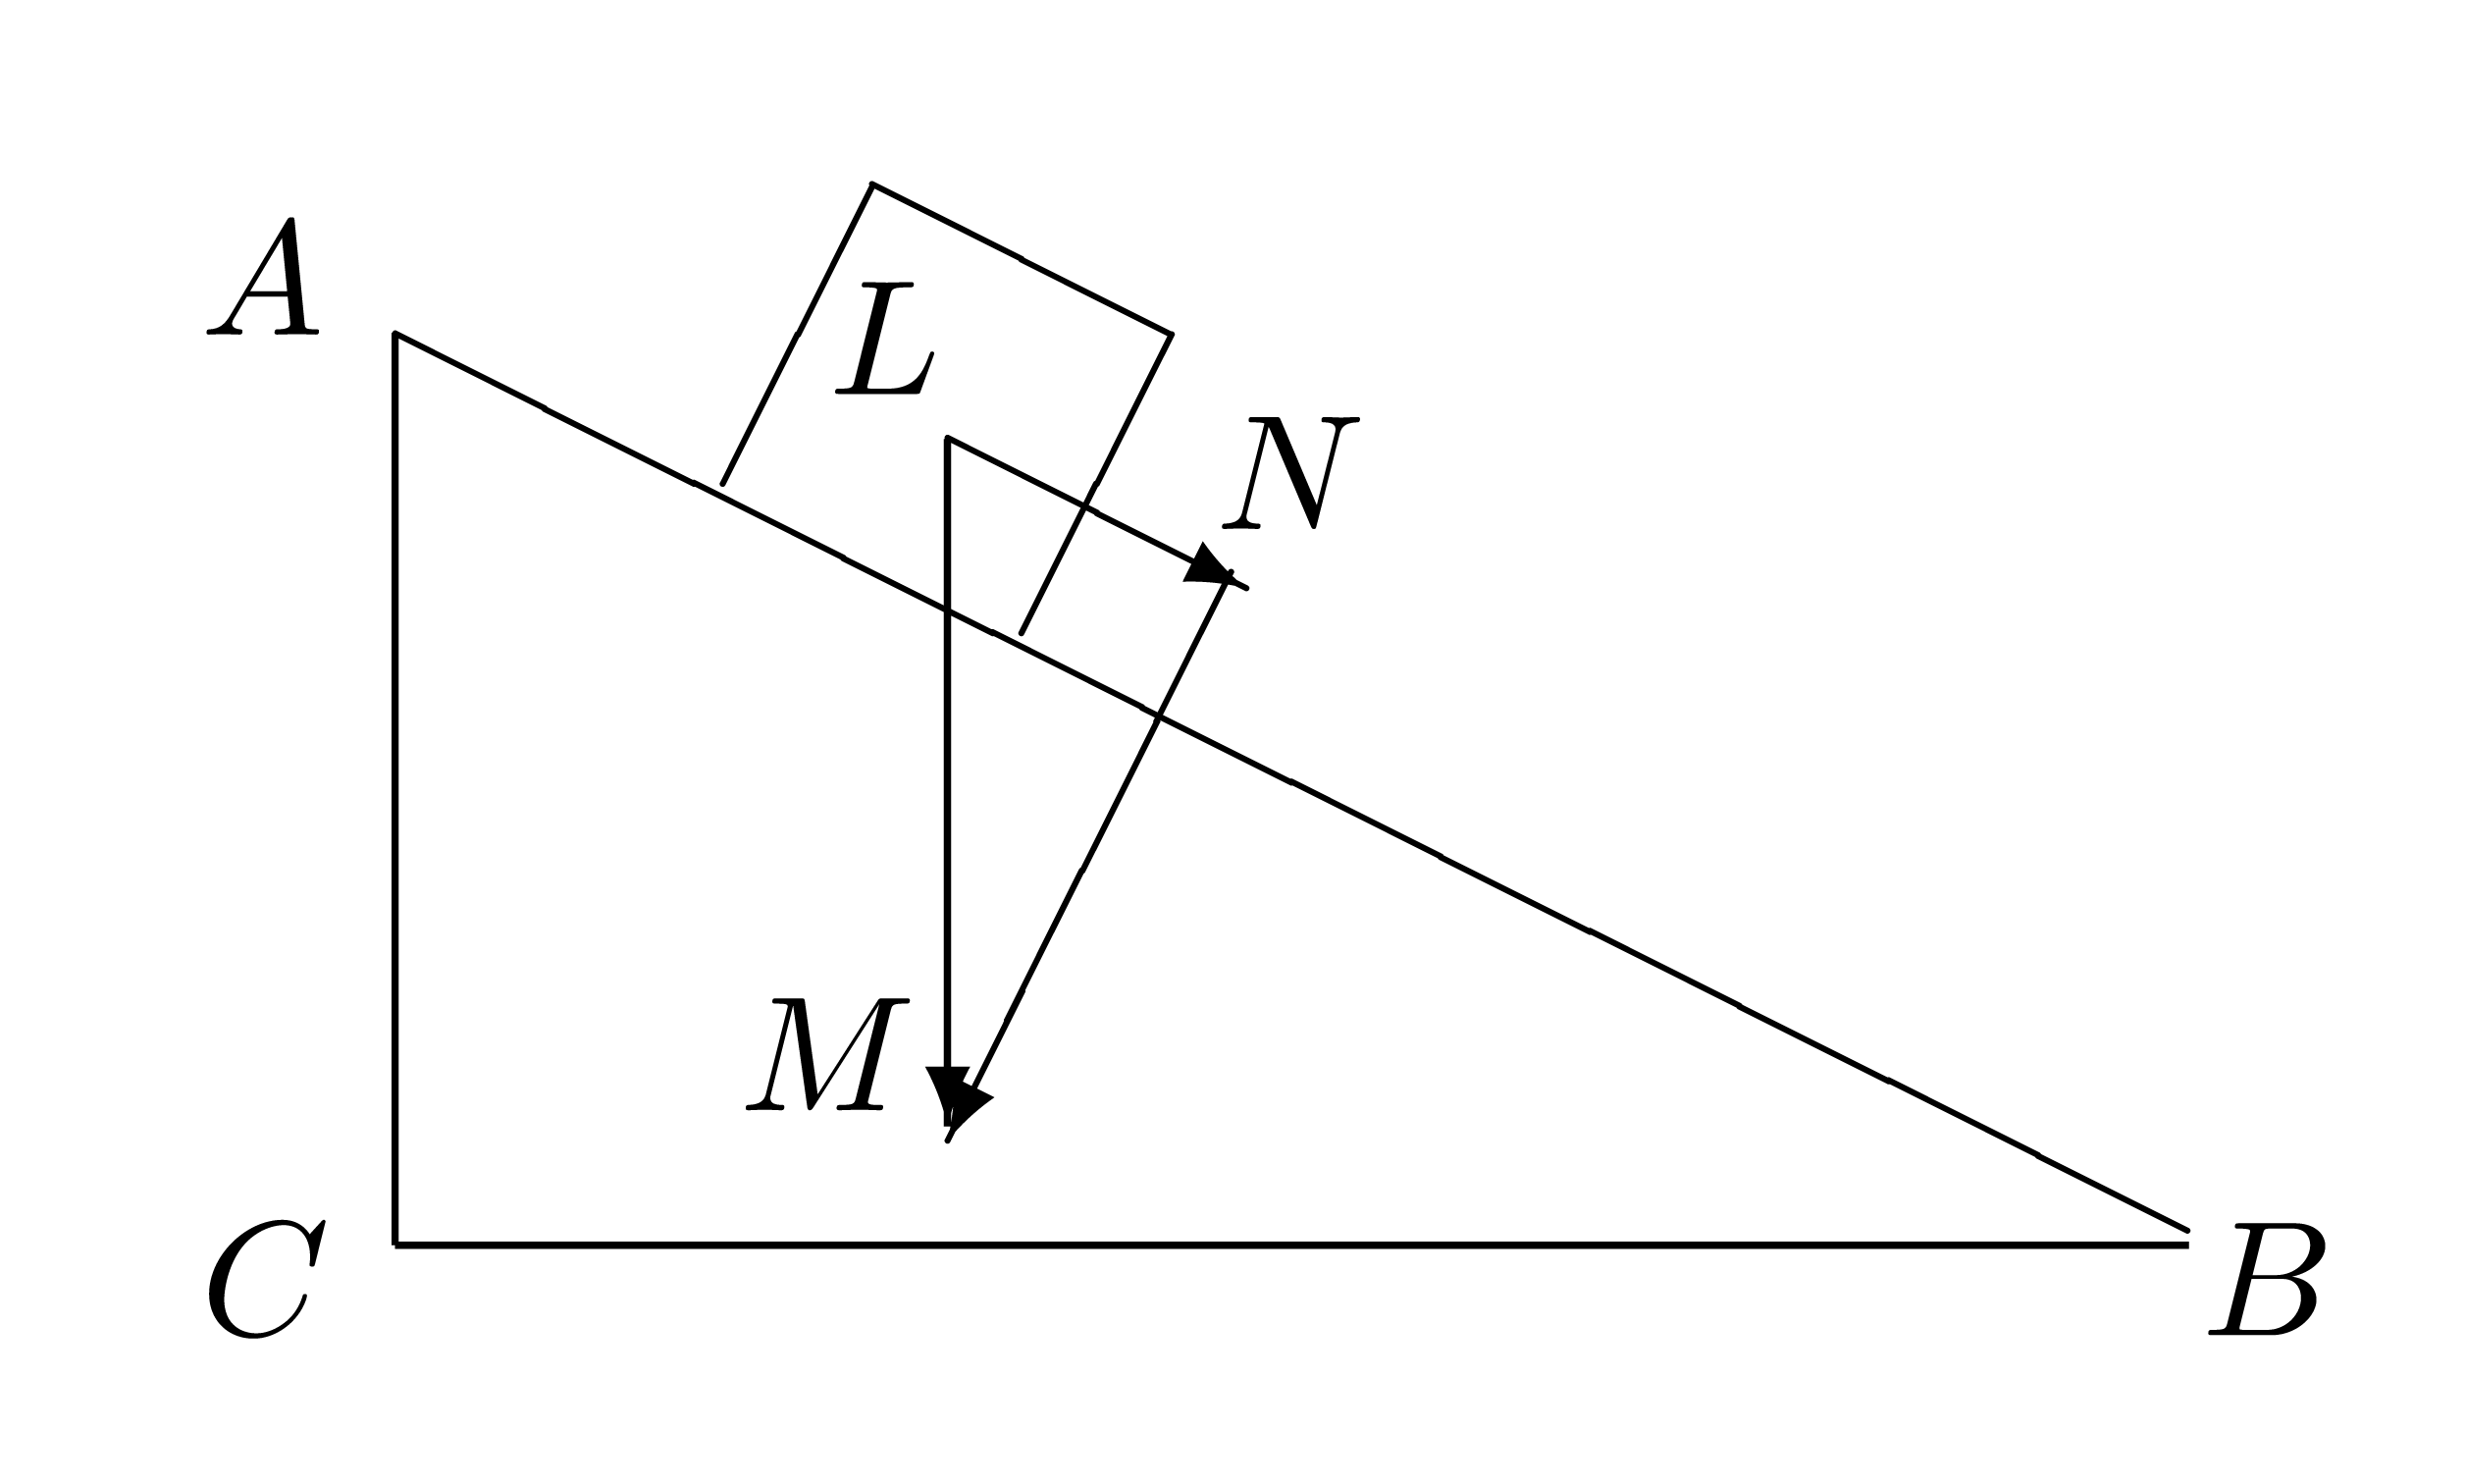
Creative Common license - http://digilander.libero.it/danilo.mauro/temi/traslazioni2.html

Solution
Since forces are perceived as pushes or pulls, this can provide an intuitive understanding for describing forces. As with other physical concepts (e.g. temperature), the intuitive understanding of forces is quantified using precise operational definitions that are consistent with direct observations and compared to a standard measurement scale. Through experimentation, it is determined that laboratory measurements of forces are fully consistent with the conceptual definition of force offered by Newtonian mechanics.
Forces act in a particular direction and have sizes dependent upon how strong the push or pull is. Because of these characteristics, forces are classified as "vector quantities". This means that forces follow a different set of mathematical rules than physical quantities that do not have direction (denoted scalar quantities). For example, when determining what happens when two forces act on the same object, it is necessary to know both the magnitude and the direction of both forces to calculate the result. If both of these pieces of information are not known for each force, the situation is ambiguous. For example, if you know that two people are pulling on the same rope with known magnitudes of force but you do not know which direction either person is pulling, it is impossible to determine what the acceleration of the rope will be. The two people could be pulling against each other as in tug of war or the two people could be pulling in the same direction. In this simple one-dimensional example, without knowing the direction of the forces it is impossible to decide whether the net force is the result of adding the two force magnitudes or subtracting one from the other. Associating forces with vectors avoids such problems.
Historically, forces were first quantitatively investigated in conditions of static equilibrium where several forces cancel each other out. Such experiments demonstrate the crucial properties that forces are additive vector quantities: they have magnitude and direction.When two forces act on a point particle, the resulting force, the resultant (also called the net force), can be determined by following the parallelogram rule of vector addition: the addition of two vectors represented by sides of a parallelogram, gives an equivalent resultant vector that is equal in magnitude and direction to the transversal of the parallelogram. The magnitude of the resultant varies from the difference of the magnitudes of the two forces to their sum, depending on the angle between their lines of action. However, if the forces are acting on an extended body, their respective lines of application must also be specified in order to account for their effects on the motion of the body.
Free-body diagrams can be used as a convenient way to keep track of forces acting on a system. Ideally, these diagrams are drawn with the angles and relative magnitudes of the force vectors preserved so that graphical vector addition can be done to determine the net force.
As well as being added, forces can also be resolved into independent components at right angles to each other. A horizontal force pointing northeast can therefore be split into two forces, one pointing north, and one pointing east. Summing these component forces using vector addition yields the original force. Resolving force vectors into components of a set of basis vectors is often a more mathematically clean way to describe forces than using magnitudes and directions. This is because, for orthogonal components, the components of the vector sum are uniquely determined by the scalar addition of the components of the individual vectors. Orthogonal components are independent of each other because forces acting at ninety degrees to each other have no effect on the magnitude or direction of the other. Choosing a set of orthogonal basis vectors is often done by considering what set of basis vectors will make the mathematics most convenient. Choosing a basis vector that is in the same direction as one of the forces is desirable, since that force would then have only one non-zero component. Orthogonal force vectors can be three-dimensional with the third component being at right-angles to the other two.

